

McAllen MRI Center

320 North McColl Rd. E

Mcallen TX 78501

Phone: 956-6879636 Fax: 956-6879743

------------------------------------------------------------------------------------------------------------

**NAME: Date of Exam: 3/16/18**

**DOB: Medical record:**

**Referral: Dr. Procedure:**

**------------------------------------------------------------------------------------------------------------**

**HISTORY:**

Thank You for your referral

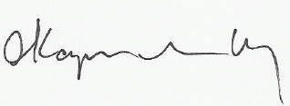

Electronically signed by:

Allan Kapilivsky M.D.

Reviewed and dictated the same day